1. Your chosen system ought to be as ubiquitous as possible. Is this possible? How would you do this? Does this affect your design?

We consider our chosen as a very common thing that people use as it is a website that people need to get themselves up to date to the latest news around the world. With that, we consider our system to be something that has a large user group.

One thing that we decided in order to make sure that people interact with the website is by making it mobile friendly and creating a native app in the tablet and mobile platform. That will allow users to visit the website and read the latest news wherever they are and whatever situation they might be in.

1. The next step of the process is to create a medium fidelity prototype. Research available prototyping tools on the web and discuss.

In this project, we used the pencil application to make the medium fidelity prototype. It is an application that provides various built-in shapes collection that can be used to design different type of interface from desktop and mobile platform.

Pencil was also the best choice for us since we learned it during the start of the semester in Human and Computer interaction module which is very advantageous as we don’t have to look for tutorials on how to use the application.

1. Using the results of your evaluation (last week) and the level of ubiquity you perceive in Question 1 above, create a medium fidelity prototype of your system.

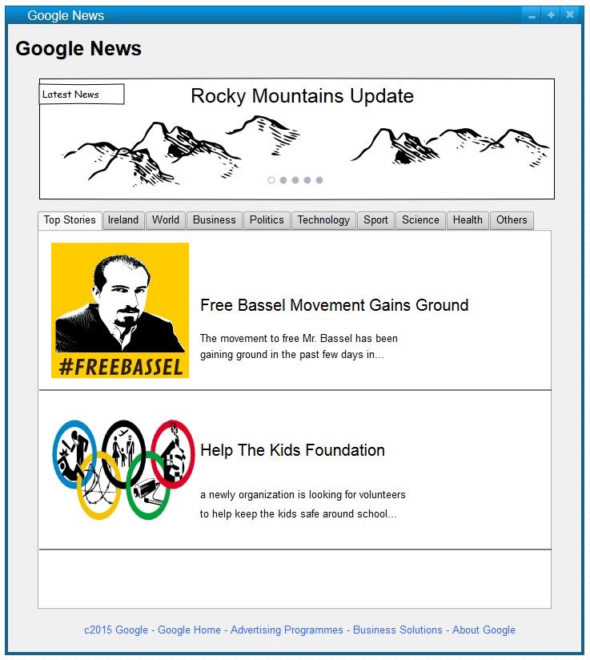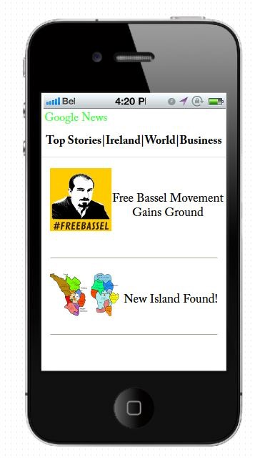

1. What HCI models can be used to evaluate your prototype?

Using the 7 stages of action model to evaluate the prototype that we have designed will allow us to clearly understand the action that we are trying to convey to the website users. It will also allow to understand better on what steps we need to do to go forward from our current prototype.

1. Evaluate your medium fidelity prototype. Do your evaluation methods differ substantially from your low fidelity evaluation methods?

The medium fidelity prototype looks more detailed than the low fidelity prototype made from previous weeks. Also, because it of using the pencil application, it is easier for internal testers to imagine how it would look like and can give out a better feedback.

In terms of evaluating the medium fidelity prototype, it didn’t differ substantially but rather became more detailed had took longer than the usual.

6. Has your design process adhered to the life cycle outlines in Week 1?

We believe we have adhered to the design process that we have chosen which was the iterative life cycle by making a basic design in week 1 and improving it on a weekly basis. We’ve also been very flexible on how we decide on the design and how we tackled different challenges encountered during the process which is one of the things that you must follow when choosing the iterative life cycle.